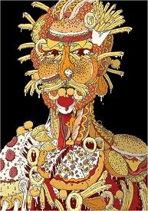
CHILDHOOD OBESITY EPIDEMIC IN CANADA
Statistics
In Canada ⅙ - ⅟₇ - ⅛ children aged 7 – 13 are obese
20% - 30% - 40% of obese children remain obese as adults
Circle the problems linked to obesity:
Poor self esteem - bad skin - type II diabetes - high blood pressure - low blood pressure - heartburn - heart disease - low blood fat - high blood fat - cholesterol - strike - stroke - cancer
The proportion of kids eating fruit & vegetables has increased / decreased
The proportion of kids eating fast foods has increased / decreased
Kids eat more: vegetables - meals - snacks - breakfasts - soft drinks - alcoholic drinks - candy bars - fruit - salt - pasta - sugar - fat
Poor N……………………………………… + In……………………………… = O…………………………………..
Complete
On average Canadian kids watch ……….. hours of TV a week, that is about ………. hours a day!
……… % of kids spend more time watching …………………….…….. and playing ………………………………….. than at ………………………………….
Now kids don’t play ………………… they play on their consoles .
Changing the situation ♥
At school teachers can promote ………………………………. Education
Regular exercise can increase / reduce stress
Strengthen / weaken the heart
Decrease / increase energy levels
Decrease / increase bone density
Increase / reduce body fat
Kids should have at least ………… hour(s) physical activity a day
A study reports that in the 15,800 Canadian schools, only ……………… % do …….………. minutes sport a day.
Teachers can - take ……………………………………………………………
- try ……………………………………………………………….
- coach ……………………………………………………………
- sponsor …………………………………………………………

